Carmandale Guinea Pig Care Sheet
Now that you have decided on a Guinea Pig as your pet you should have all the supplies necessary before bringing him/ her home. A safe and enjoyable home will help you have a happy and healthy Guinea Pig. This care sheet will guide you in having everything you need.
What are they?
The domestic guinea pig (Cavia porcellus), or simply guinea pig, also known as cavy or cuy as livestock, is a species of rodent belonging to the family Caviidae and the genus Cavia.

Despite their common name, these animals are not in the pig family Suidae, nor do they come from Guinea. They originated in the Andes, and earlier studies based on biochemistry and hybridization suggest they are domestic descendants of a closely related species of cavy such as Cavy aperea, Cavy fulgida, or Cavy tschudii and, therefore, do not exist naturally in the wild.
The domestic guinea pig plays an important role in the folk culture of many Indigenous South American groups, especially as a food source, but also in folk medicine and in community religious ceremonies.

In Western societies, the domestic guinea pig has enjoyed widespread popularity as a household pet since its introduction by European traders in the 16th century. Their docile nature; friendly, even affectionate responsiveness to handling and feeding; and the relative ease of caring for them, continue to make guinea pigs a popular pet. Organizations devoted to competitive breeding of guinea pigs have been formed worldwide, and many specialized breeds of guinea pig, with varying coat colors and compositions, are cultivated by breeders.

What Guinea pigs should look like as per the SAGPS standard?

- Shape/Size The outline should consist of a gentle curve rising from the nostrils to the shoulders, then dipping to the back and briefly once more before dipping over the hindquarters.
The body should be short and coby with deep, broad shoulders.
Size is very desirable but not at the expense of cobiness and quality
- Head The ideal shape is a compact and broad nose, giving plenty of space between the eyes and ears.
The profile of the head should be “Roman” and NOT snipey.
The head to be wide and moderately blunt.
- Ears Large petal shape, set fairly low on the sides of the head.
They should drop slightly, giving a droopy ear effect set on the side of the head.
- Eyes Big, Bright and Bold

- Body Shape 20%
- Head 10%
- Eyes 10%
- Ears 10%

How do Guinea Pigs behave?

• They are generally very well behaved and affectionate animals.
• Guinea pig breeds thrive with company and prefer to be around other cavies. If not they require the attention of the owner for a few hours a day.

How to look after your Guinea Pig/s

• Their average lifespan is 4.5 years but tend to live up to 5 – 6 years with proper care. There are Guinea pigs that have lived to be 7 years old.
• Guinea pigs do not need to bathe often because they need the protection of the oils that their bodies produce.

What should I look for in a cage?

Many of the cages marketed for guinea pigs today are entirely too small. It's important when choosing the right cage for your cavy that you make sure the cage provides plenty of space to run and play. The minimum cage size recommended by RSPCA for two guinea pigs should be 120cm x 60cm x 45cm, however for the sake of your guinea pig's health and happiness, consider providing as large a cage for them as possible.

The minimum cage sizes are:

• One guinea pig: 100cm x 50cm
• Two guinea pigs: 120cm x 60cm
• Three guinea pigs: 140cm x 70cm
• Four guinea pigs: 150cm x 80cm

Other cage features you should look for include:

• Safe, escape proof, materials.

The safest cages are made from plastic, wire, stainless steel, or a combination of these materials. Wood cages are easily chewed through and glass cages don't provide enough ventilation.

• No wire mesh flooring

Housing your guinea pig on a wire floor will hurt his sensitive feet and can cause a condition called bumble foot, so if your cage has a wire floor, which many do, be sure to cover it with cage mats.

• Latching door or lid

This will keep your guinea pig in and other animals out.

• Spacious enough to provide ramps and activity areas

Though guinea pigs aren't agile and don't climb very well, they do need places to play and explore.

Example of Skinny Pig Cages available in South Africa from www.pethabitat.co.za

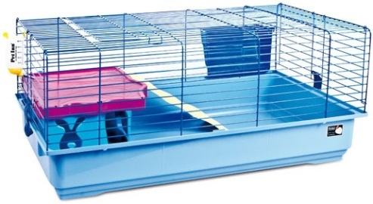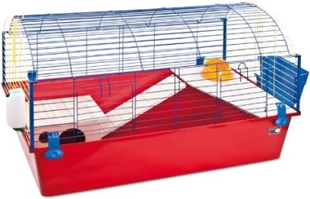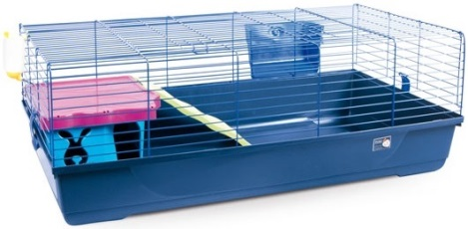

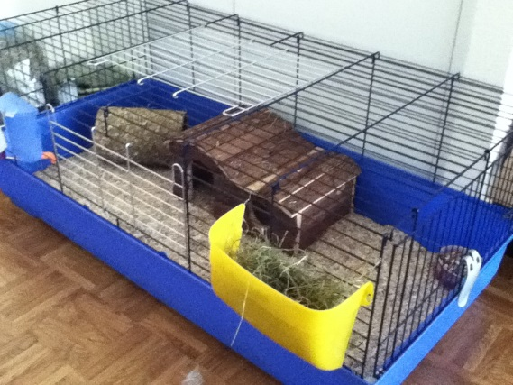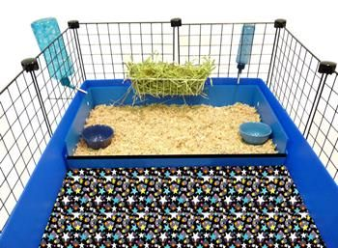
Example of some simple Skinny Pig Runs set up for indoors
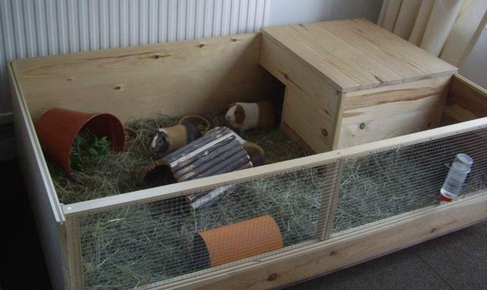
Example of Skinny Pig Cages available in South Africa from www.cozypets.co.za
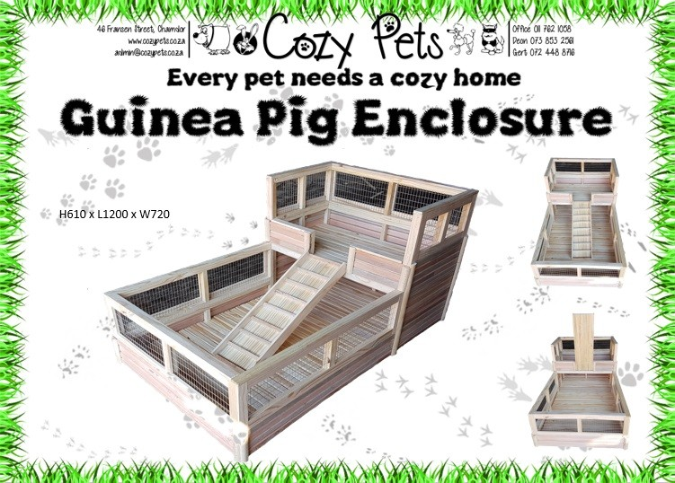

What should I put in the cage?
What you put in the cage is just as important as what size the cage is. A large cage without the necessary accessories is going to be boring for your guinea pig, and it will eventually have a negative effect on his physical and mental state.
The following items should be in your Guinea pig's cage:
• A place to hide, such as a nest box or large diameter PVC pipe and even used shoe boxes work well.
• A heavy ceramic food dish as they tend to knock over there food dishes but small enough that they can't climb in it and use it as a toilet.
• Plastic or glass water bottle with a metal spout for water.
• A hay rack to keep hay clean, fresh, and off the floor.
• Wood shavings, pelleted organic corn cat litter, straw bedding or changeable material. Just make sure if you are to use blankets or material to have a small litter box for them to use with wood shavings or an organic corn cat litter. (Clumping clay litter is unadvisable as they can digest it and cause problems.)
• Ramps and other furniture for them to explore.
• Low plastic shelves.
• Toys such as tunnels, tubes, wooden chew toys, wood blocks, paper bags, and hanging bird toys are excellent.
Be sure that whatever you put in the cage doesn't interfere with the space he needs to run around and exercise.
What not to add to their cages?
Exercise balls and wheels are appropriate for some small pets like rats, mice, gerbils and hamsters, but they should never ever be used for guinea pigs. Even if the product is specifically labeled or marketed for guinea pigs please do not use one.
Cavies have a different anatomy and they can badly injure their backs with an exercise ball or wheel. Also, a ball is too enclosed and doesn't provide enough air circulation which can lead to heat stroke - the condition is often fatal for Guinea pigs.

How to give your Guinea Pig extra safe exercise
If you want your guinea pig to safely get enough exercise, buy the largest possible cage and give your pet floor time in a safe area.
Lap time is also an important part of a guinea pig's day. Although not all piggy’s are cuddly, many love time out of their cage to sit on their owners' laps. Always hold your guinea pig in a towel to protect yourself from toilet accidents.
Where should I put the cage?
The cage should be in a relatively quiet area without a lot of noise & commotion. It should be out of direct sunlight, and the temperature of the room should stay between 18° and 23°C. Temperatures below 15°C and over 27°C can be dangerous, so you must absolutely place your guinea pigs cage indoors where temperatures are regulated. Be sure to put it in a well ventilated area. Once you have the perfect cage and setup, be sure to clean the cage daily to keep your guinea pig happy, healthy, and safe.
Food, Diet & Supplements:
Vitamin C
Vitamin C is of utmost importance to guinea pigs, as they are unable to manufacture their own (much like humans). Without enough vitamin C in their diets, guinea pigs can become very ill with scurvy. The amount of vitamin C required varies somewhat depending on the reference source used, but most guinea pigs probably need about 10-30 mg/day. Pregnant, nursing, young, and ill guinea pigs need more.
If you feed a good selection of vegetables high in vitamin C along with a good, fresh guinea pig pellet, you can probably meet the vitamin C needs of the average guinea pig.
Many guinea pig pellets have vitamin C added but, unfortunately, vitamin C is quite unstable and will degrade over time. Keeping the pellets in a cool dark place helps preserve the vitamin C. You can also get pellets with a stabilized form of vitamin C.
The best way to supplement with additional vitamin C is to use vitamin C tablets. You can buy vitamin C tablets specifically for guinea pigs (e.g. Oxbow's GTN-50C), or buy human chewable 100 mg tablets (note: make sure you are getting just vitamin C rather than a multivitamin formula). A quarter of a 100 mg tablet daily is a recommended dose for most adult guinea pigs. The guinea pig tablets are 50 mg, but since vitamin C is a water-soluble vitamin, small excesses over that daily requirement are easily excreted. Many guinea pigs will take the tablets like a treat and eat them, or they can be crushed and sprinkled on vegetables or pellets.

What we do for our Cavies
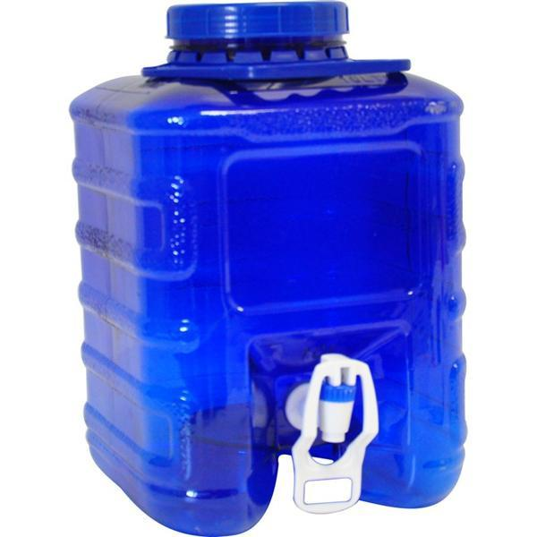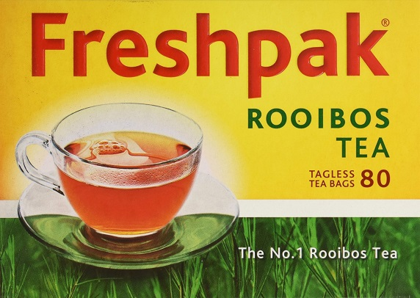
In a ten liter Square Water dispenser from Westpac I add 1 x tea bag newly boiled Rooibos tea with 2 tablets of plain Dischem 500mg Vitamin C, 1 teaspoon Phenix Stresspac and through in a bunch of freshly picked Parsley of which I dispense into their water bottles freshly every day. Making sure to make a new mixture twice a week,
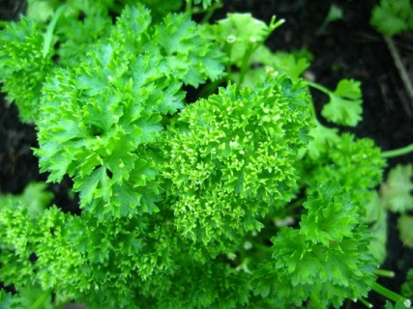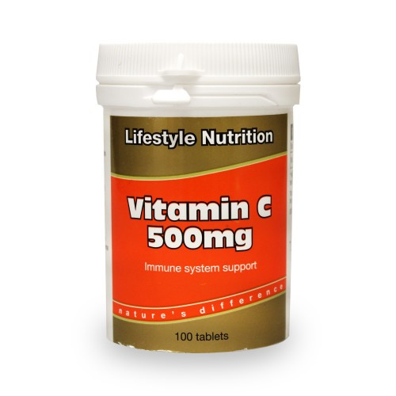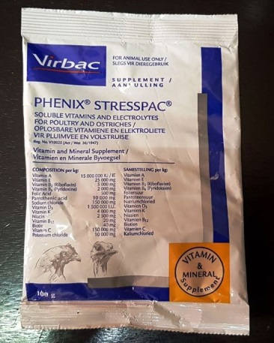
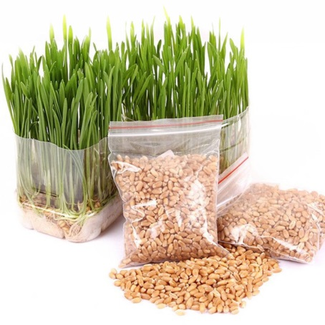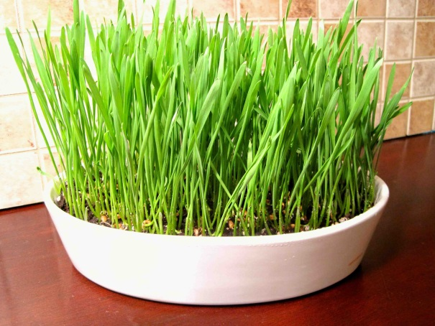
Every morning I feed whole freshly sprouted Wheat shoots

Why whole freshly sprouted Wheat shoots?
Sprouting grains increases many of the grains' key nutrients including B vitamins, vitamin C, folate, ﬁber, and essential amino acids often lacking in grains such as lysine. Sprouted grains may also be less allergenic to those with grain protein sensitivities.
Vitamin C can be added to the water, but there are problems with this method. The vitamin C quickly loses its potency in water (a fresh supply must be made at least daily, if not twice daily). Also, guinea pigs may refuse or reduce their consumption of water with added vitamin C due to the taste, and this may lead to other health problems. It is also very hard to know if your guinea pigs are getting enough vitamin C using this method of supplementation. Feeding a variety of fresh veggies high in vitamin C and/or supplementing directly with tablet forms of vitamin C are better options.
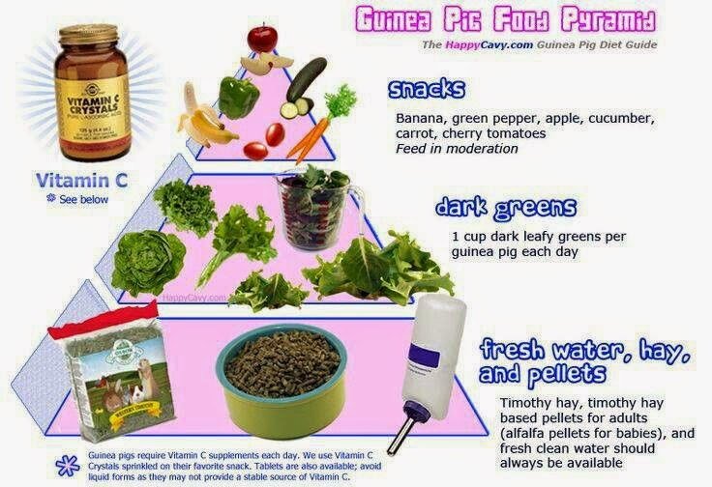

Pellets
Commercial guinea pig pellets should be fed daily. Most guinea pigs will not overeat (usually eat about 1/8 cup per day) but the amount of pellets may need to be restricted if a guinea pig becomes obese. Choose a good quality pellet designed guinea pigs. Since the vitamin C in pellets also loses its potency over time, look for pellets that use a stabilized form of vitamin C, or at least one with a "use before" date ensure freshness, and also buy in small quantities and store in a cool dark place.
For growing guinea pigs, alfalfa based pellets are fine, but for adults, it may be better to search out a Timothy hay-based pellet. A couple of excellent Timothy-based diets include Oxbow Hay's Cavy Cuisine, and KM Hayloft's Timothy's Choice.
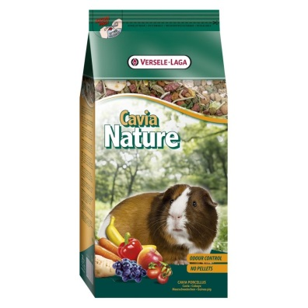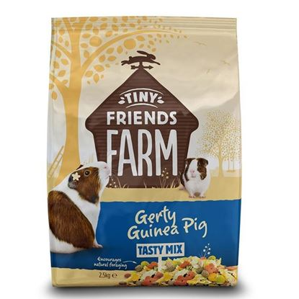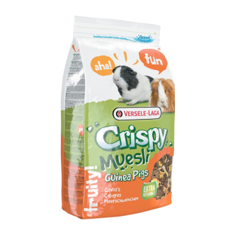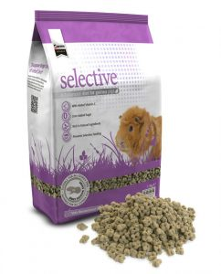
When choosing a guinea pig diet or pellet, avoid those with nuts or seeds, dried fruits, corn products, animal by-products, or ​beet pulp or other fillers. Also watch for high sugar content (sucrose, fructose, corn syrup, etc) and foods with lots of preservative or added chemicals. The Guinea Lynx site has a great article on selecting good quality pellets.
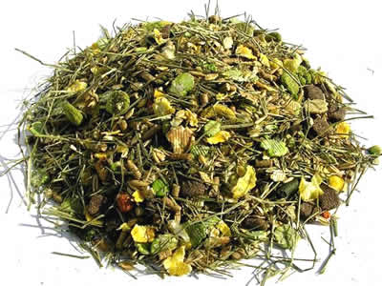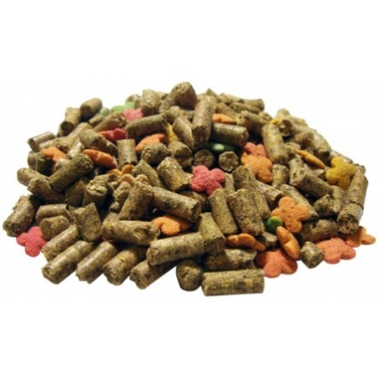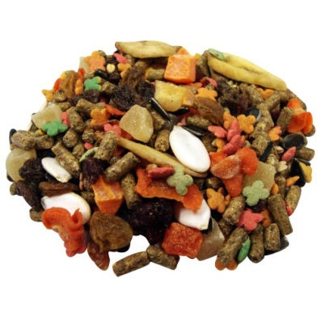
Look for food with higher levels of hay in and less fruit & nuts as this type of food should be kept more for treats.
Fresh Hay
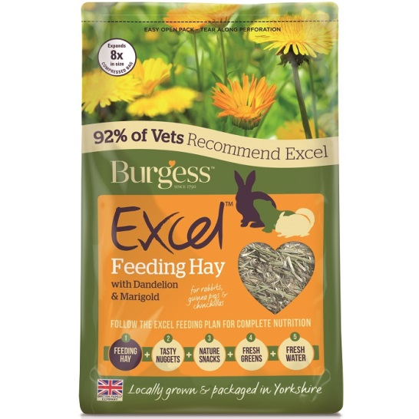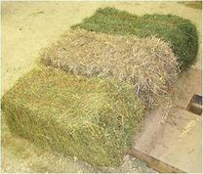
Hay should be a staple in the diet and a fresh supply available at all times. Grass hays such as Timothy hay or orchard grass are the best for adult guinea pigs.
Alfalfa is richer and higher in calcium and is a good supplement for growing guinea pigs as well as pregnant or nursing guinea pigs, but is not a good staple for most adult guinea pigs.
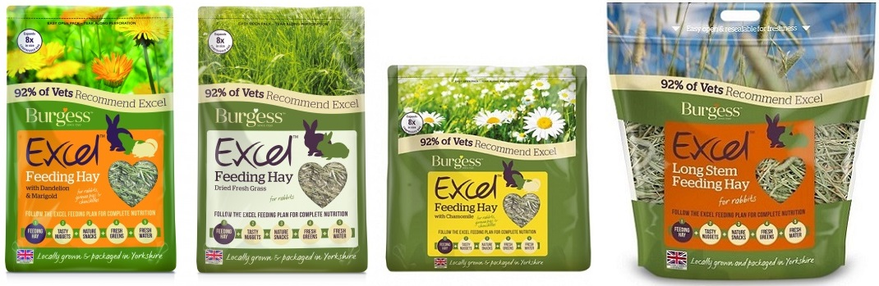
Fresh Vegetables and Fruit
In addition to the hay and pellets, a variety of fresh vegetables (especially leafy greens) and some fruits should be offered daily. Leafy greens should make up the bulk of the vegetable supplementation, and fruits and other vegetables can be offered in small quantities. Avoid iceberg (head lettuce) as it has very little nutritional value. Good choices include kale, spinach, turnip greens, parsley, romaine lettuce, and dandelion greens. Avoid or limit cabbage, broccoli, cauliflower, collards, bok choy and other cruciferous vegetables as they can lead to gas production in the digestive tract.
Try avoid starchy vegetables like potatoes.
Carrots, carrot tops, green and red bell peppers, apple, apricots, bananas, blueberries, cantaloupe, grapes, oranges, strawberries, and tomatoes can also be fed. If you have a guaranteed pesticide-free source, grass, dandelions, clover, and chickweed can also be offered, especially new growth which is tender and the most nutritious.
Any greens, vegetables or fruits should be introduced gradually or a digestive upset may result.
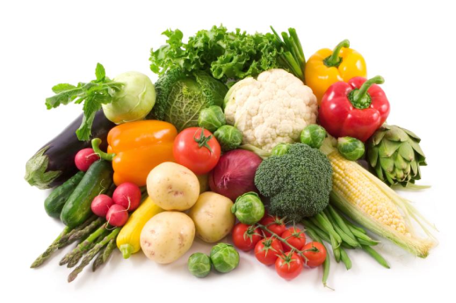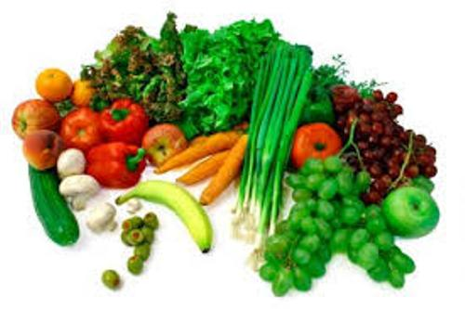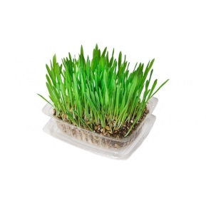
As much variety of fresh greens, fruit and vegetables on top of their hay, pellets and water for added health & vitality. Remember freshly sprouted seed like Oats, Barley or wheat is fantastic for added nutrition.

Here is just a partial list of safe fruits and veggies that you can feed your Skinny Pigs:
Veggies  • Artichoke  • Asparagus  • Avocado  • Bamboo Shoots  • Beats  • Beet Greens  • Broccoli (Spears & Sprouts)  • Brussels Sprouts  • Cabbage (Green & Red)  • Carrots  • Cauliflower  • Celery  • Collard Greens  • Coriander  • Corn (yellow)  • Cucumber(With or Without skin)  • Dandelion Greens  • Eggplant  • Ginger Root  • Green Beans (Snap Beans)  • Spaghetti Squash  • Zucchini  • Sweet Potato  • Tofu  • Turnip Greens  • Peas  • Peppers (Sweet)  • Pumpkin  • Spinach  • Yams | Fruits  • Apple (With or Without skin)  • Apricots  • Banana  • Blackberries  • Blueberries  • Cantaloupe  • Cherries (Sweet)  • Cranberries  • Currant  • Dates  • Figs  • Grapes  • Grapefruit  • Honeydew Melon  • Kiwifruit  • Kumquat  • Mango  • Nectarine  • Orange (Navel & Valencia)  • Papaya  • Passion Fruit (Purple)  • Peach  • Pear  • Pineapple  • Plantain  • Plum  • Pomegranate  • Prickly Pear  • Prunes  • Raspberries  • Strawberries  • Tangerine  • Watermelon

Avoid feeding your Skinny Pigs any seeds!
Toxic foods to NEVER feed your Skinny Pigs:
- Onion
- Garlic
- Lima Beans
- Chocolate
- Rhubarb
Water
Skinny Pigs drink quite an amount of water due to the majority of dry foods in their diet, freshly mixed water as suggested above should always be available for your pet. A pet dispensing water bottle is a great way to keep water available.
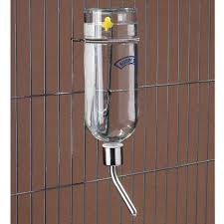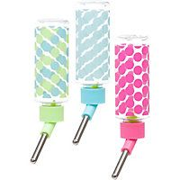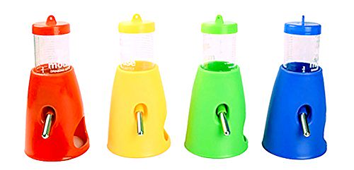
A variety of available water bottles to attach to the outside of the cage or inside
Please note: DO NOT GIVE your Guinea Pig CHOCOLATE!! As with other animals, during digestion a toxin can be created. It may be harmful to Guinea Pigs as well, and certainly not worth the risk!
Taming & Bonding With Your Guinea Pig
A tame guinea pig is truly a much happier and more enjoyable pet for several reasons. Taking the time to properly bond with your piggy will ensure a much better relationship over the lifetime of your pet. Not only will they be a better pet, they will have a better quality of life and will come to enjoy your company and seek out your attention. A super tame guinea pig can be almost dog-like in personality, and often follow their person around like a puppy. :)
A guinea pig that truly enjoys being with you and receiving affection is really a special pet. In addition to this, a tame guinea pig is much more trainable and will learn new tricks significantly faster than one that is nervous of you and their environment. Further down this page, you can find some tips for bonding with your guinea pig. Remember that in order to properly bond with your guinea pig, you should be prepared to spend time with them consistently every day, regardless of the method(s) you choose to try.
Spend Lots of Time With Your Piggy!
The best way to tame and bond with a guinea pig is to simply spend lots of time with them in a positive manner. This essentially means you let them come to you, and offer veggies whenever they approach. An enclosed environment such as an exercise pen or a dry bathtub with towels laid out is a great place to sit with them and let them come to you.
Offer some food when they approach you, so they associate you as something positive, rather than a potential predator. If your piggy won't come close enough to take food from your hand, lightly toss the food to them whenever they come in your direction, and wait until they come a little closer each time before offering the food. Talk to them in a happy voice and offer their favorite veggie treats.
Hanging out with your piggy frequently and consistently is key to having a sweet and social piggy, and forming a solid bond between you. When your piggy is comfortable approaching you and taking food from your hand, you can start having them come onto your lap to get the food, first by rewarding for putting their front paws up, then luring them onto your lap all the way with the food. If you can get your piggy doing this consistently for their veggies, you'll be in a really good position to start teaching tricks, as this demonstrates that the guinea pig is comfortable around you, and will follow a lure in the form of food.
If your guinea pig won't eat veggies in your presence at all, you can still form a positive association with yourself by draping a blanket over your leg and onto the floor to form a tent for the guinea pig to hide in. This gives the guinea pig a place to hide and feel comfortable while also getting used to being near you, rather than running away and hiding from you. Some people also put the guinea pig on their lap with a blanket or baggy sweater and let them bury themselves inside. This is another way to keep the guinea pig comfortable while in your presence until they are no longer scared of you.
Guinea Pigs That Run When You Try to Pick Them Up
As prey animals, guinea pigs are instinctively nervous of shadows, and anything coming at them from above. In addition to this, guinea pigs also have poor eyesight, so tend to spook easily as a safety reflex. It is always a good idea to talk to your piggy as you're approaching their cage and reaching in, so they know it is you. It's also a good idea to pet the guinea pig a little before actually lifting them up as well, to give them a heads up of your intentions.
However, regardless of how familiar your guinea pig is with being picked up, or how consistently you let your piggy know of your intentions, he/she will still likely still be a little weary of being picked up. This is normal for a prey animal, and is to be expected. They are going to be most comfortable with their feet on the ground, in control of their own actions.
Socializing with New People & Different Environments
Everyone that has had a guinea pig knows that your piggy can be the sweetest little rascal when hanging out with you, coming up to you and seeking out attention and treats, and then completely disappear the second a stranger enters the room. Or the piggy that happily explores every corner of the room they are used to, yet freezes in fear when brought to a new room 5 steps away from their usual place. Piggy’s are very programmed around their routine and everything in it, and are completely thrown off when anything changes, even in the slightest.
You may want to get the guinea pig used to other people and places for various reasons. If you teach your guinea pig tricks and want to show other people what your piggy can do, you will definitely want him/her to be socialized a bit with other people. Otherwise, your guinea pig will be unlikely to perform any tricks with someone watching. ;)
To socialize your piggy with other people, you can basically just have another person sit in an enclosed space with your piggy, and have the person give the guinea pig a treat whenever the piggy approaches them. You can do this a few times for each person, and repeat the process with a few different people.
Getting a guinea pig used to new places is a bit more time consuming, but the more places you get your piggy accustomed to, the more adaptable they should be with new places in the future. To introduce a guinea pig to a new room or area, try starting out by putting a pen up to fence off a small portion, to let the piggy roam in just a small area of the new room. Bring the guinea pig back a few different times; making the space they have to explore a bit bigger each time. A more confident guinea pig might be happy to explore the whole area all at once, so if you have a piggy like that, you can give them access to more space right away if you want. It will probably take any guinea pig quite a while to be completely comfortable in a new place though, so lots of time and patience is essential. :)
Taming Tips!
• Guinea pigs are more comfortable with a routine; this is particularly important if they are new to your home and unsure of their surroundings. Being fed, held, and let out of their cage to run around are all activities that your guinea pig will be more comfortable with if they occur around the same time each day. Guinea pigs feel more secure and safe if they know what to expect. Try to pick a time for each of these activities and stick to it as much as possible.
• Be careful not to make too many loud noises or sudden movements around your guinea pig. The less they are scared of you, the quicker they will come to trust you.
• Try hand feeding your guinea pig in their cage or anywhere where they seem most comfortable.
• You can also try putting treats in your guinea pigs cage a few times a day. Don't worry if your piggy doesn't come out at first. They will come to associate you approaching their cage with being fed rather than think of you as a potential predator
• If you have a more confident guinea pig that lives with the one you are working with, get them out together for floor time and sit with them. Being out with a more confident guinea pig may help the nervous guinea pig to feel more comfortable and willing to follow the example of the other guinea pig.
• Be prepared to spend time bonding with a New Guinea pig, even if their previous owners say the piggy has been handled frequently and is tame. The guinea pig will still need time to bond with their new owners and get used to their new environment. If a guinea pig is already used to being handled, that's great, and definitely speeds up the process, but still does not fully eliminate it.
• While some people may think that an older guinea pig will never become tame, this is simply not true. A guinea pig of any age will become tame if you take the time to make it happen.
• Try to interact with your guinea pig mostly in the places where they feel most comfortable. For example, if you are getting the guinea pig out of their cage to hold him/her, choose a quiet place, preferably a room that they are familiar with, like the room their cage is located in, or the area where they are allowed to roam for floor time. You want your guinea pig to feel as comfortable around you as possible. After all, if every interaction between you and your guinea pig is stressful and frightening for your pet, they will be unlikely to enjoy spending time with you.
• The main goal is to create as many positive associations between you and your guinea pig as you can. This pretty much means you will likely use lots of food early on as you begin to bond with your pet. These positive food associations will help your guinea pig to overcome their fear of you and associate you with good things rather than just being scary. Once your piggy becomes more comfortable around you, they tend to enjoy incorporating you into their floor time, and checking in with you every 5 seconds. :) It takes time and patience to develop a true bond with your piggy, but it is worth any effort! Guinea pigs can become quite close to their favorite person, and almost seem to turn into little puppies in terms of affection and behavior.
Overall, the key to taming and bonding with a guinea pig is to spend lots of time with them and be consistent. Guinea pigs really thrive when you spend the time with them to bring them out of their shell. Patience does pay off Bonding with your new Skinny Pig
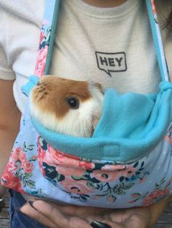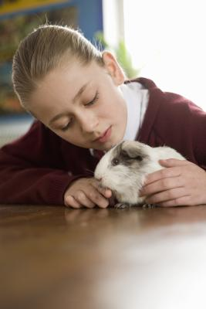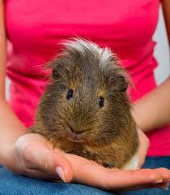
Final Words
Thank you once again for giving our baby a wonderful home and welcome to the Carmandale family! Good luck, enjoy your new baby and should you have any challenges, questions or concerns; please don't hesitate to call.
Should your circumstances change and you are unable to keep your Skinny Pig, please contact me and we will gladly assist you in re-homing them.
We will gladly look after your baby if you are going away on a holiday and need assistance in your time away for a nominal fee to cover their food & stay.
This is our hobby and each and every one of our babies are brought up with love & care and we appreciate all your news, pictures and updates.
All the best and warm regards,
The Carmandale Guinea Pig Team!
Shaun Armand: 082 719 0110
Email: carmandale@gmail.com
Website: www.carmandaleguineapigs.weebly.com

